Practical No 8

Aim:- Write a C program to simulate the following Disk scheduling algorithms
- FCFS b)SSTF

Theory:-
In operating systems, seek time is very important. Since all device requests are linked in queues, the seek time is increased causing the system to slow down. Disk Scheduling Algorithms are used to reduce the total seek time of any request.
First-Come-First-Served (FCFS) Scheduling
This is the simplest form of disk scheduling in which the first request to arrive is the first one serviced. FCFS has a fair policy in the sense that once a request has arrived, its place in the schedule is fixed irrespective of arrival of a higher priority request. FCFS is easy to program, however, it may not provide the best service. Consider, for example, disk queue with requests involving tracks to read,
100, 200, 50, 150, 25, 155, 70 and 85
The starting track to read is 100 and the last one is 85.
If the head position of a disk system is initially at 50, it will first move from 50 to 100, then to 200, 50, 150, 25, 155, 70 and 85 for a total head movement of 755(100-50) + (200- 1 00) + (200-50) + (150-50) + (150-25) + (155-25) + (155-70) + (85-70) tracks.
One drawback with this scheduling approach as seen in the figure 9 is that there is a big swing from 150 to 25 and back to 155. If the request for reading or writing tracks 50 and 25 and serviced together either before or after the requests of 150 and 155, then the total head movement will be drastically reduced, thus increasing disk throughput.
FCFS is acceptable when the load on a disk is light But as the load grows, FCFS tends to saturate the device and response time becomes longer..

Program:-

#include<stdio.h>
#include<conio.h>
int main()
{
int t[20], n, i, j, tohm[20], tot=0;
float avhm;
clrscr();
printf("enter the no.of tracks:");
scanf("%d",&n);
printf("enter the tracks to be traversed:");
for(i=1;i<n+1;i++)
scanf("%d",&t[i]);
for(i=1;i<n+1;i++)
{
tohm[i]=t[i+1]-t[i];
if(tohm[i]<0)
tohm[i]=tohm[i]*(-1);
}
for(i=1;i<n;i++)
tot+=tohm[i];
avhm=(float)tot/n;
printf("Tracks traversed\tDifference between tracks\n");
for(i=1;i<n;i++)
printf("\t%d\t\t\t%d\n",t[i],tohm[i]);
printf("\t%d\t\t\t0\n",t[i],0);
printf("\nAverage header movements:%f",avhm);
getch();
return 0;
}

Output:-

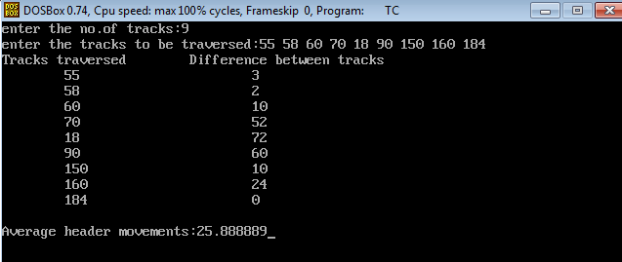

Shortest-Seek-Time-First Scheduling
In Shortest-Seek-Time-First (SSTF) scheduling priority is given to those processes which need the shortest seek , even if these requests are not the first ones in the queue. It means that all request nearer to the current head positions are serviced together before moving head to distant tracks. Since seek time is generally proportional to the track difference between the requests, this approach is implemented by moving the head to the closest track in the request queue.
Considering the previous example of request queue of 100, 200, 50, 150, 25, 155, 70 and 85 tracks, the nearest track for a service from an initial head Position (50) is at track 70. Once we are at 70, the next closest track is 85 (the difference is of 15 tracks only). From here it can go to 100. Continuing this way, the request for track 155 is serviced next and then switch over to 200 and finally at 25.
Using SSTF scheduling yield 325 ((70 - 50) + (85 - 70) + (100 - 85) + (150 - 100) + (155 - 150) + (200 - 155) + (200 - 25)), less than a half of distance required for FCFS, which is a substantial improvement in disk throughput. SSTF is essentially a form of Shortest Job First (SJF) Scheduling and like SJF it can create the shortage of requests. In real System, requests arrive randomly. Suppose there are three requests 10, 20 and 150. If read/write he is near 10 then 10 and 20 will be served and 150 will be kept waiting. If another request comes which is nearer 20, 150 will have to wait further. Theoretically, a continued stream of requests near each other could arrive, causing the request for track 150 to wait for a very long period.
SSTF tends to discriminate sharply against certain requests. SSTF services requests for those tracks which are highly localized due to which the innermost and outermost tracks can receive poor service compared with the mid-range tracks.

Program:-

#include<stdio.h>
#include<conio.h>
main()
{
int t[20], d[20], h, i, j, n, temp, k, atr[20], tot, p, sum=0;
clrscr();
printf("enter the no of tracks to be traveresed:");
scanf("%d'",&n);
printf("enter the position of head:");
scanf("%d",&h);
t[0]=0;t[1]=h;
printf("enter the tracks:");
for(i=2;i<n+2;i++)
scanf("%d",&t[i]);
for(i=0;i<n+2;i++)
{
for(j=0;j<(n+2)-i-1;j++)
{
if(t[j]>t[j+1])
{
temp=t[j];
t[j]=t[j+1];
t[j+1]=temp;
}
}
}
for(i=0;i<n+2;i++)
if(t[i]==h)
j=i;
k=i;
p=0;
while(t[j]!=0)
{
atr[p]=t[j];
j--;
p++;
}
atr[p]=t[j];
for(p=k+1;p<n+2;p++,k++)
atr[p]=t[k+1];
for(j=0;j<n+1;j++)
{
if(atr[j]>atr[j+1])
d[j]=atr[j]-atr[j+1];
else
d[j]=atr[j+1]-atr[j];
sum+=d[j];
}
printf("\nAverage header movements:%f",(float)sum/n);
getch();
return 0;
}

Output:-
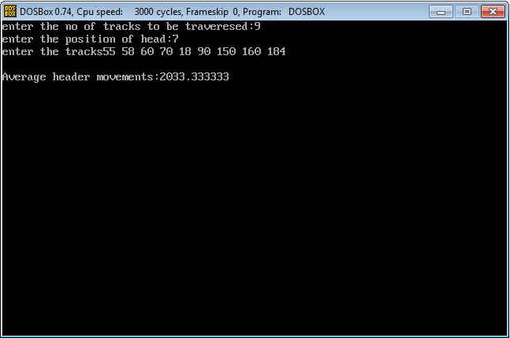

Result:-
Thus, FCFS & SSTF Algorithm for Disk scheduling has been studied & Program successfully executed.

